Answer any four questions

1 | Cyclohexylethanone undergoes two particular chemical reactions as shown.  I  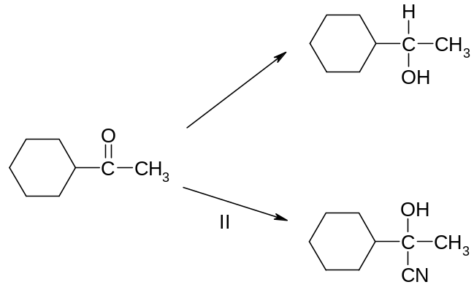
(a) | (i) | State the reagents and conditions required for steps I and II.
 | (ii) | Explain why the product in step II is optically inactive.
 |  | [5]
(b) | Cyclohexylethanone also reacts with a Grignard reagent as follows.  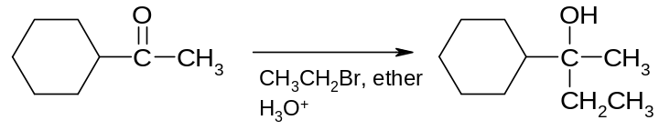  CH₃CH₂MgBr, ether / H₃O⁺  The Grignard reagent CH₃CH₂MgBr is generated via the reaction of Mg with CH₃CH₂Br  in ether solution.
 | (i) | State the function of the Grignard reagent in this reaction.
 | (ii) | Hence by means of equations, describe the mechanism in (b)(i).
 |  | [5]
(c) | Magnesium is a Group II element that forms a wide variety of ionic compounds such as magnesium nitrate.
 | (i) | Write a general equation to represent the thermal decomposition of the Group II metal nitrates.
 | (ii) | Describe how the thermal decomposition temperature of the Group II nitrates varies down the group. Suggest an explanation for this trend.
 |  | [5]
(d) | Another naturally occurring mineral is haematite, Fe₂O₃ in which Fe exists as Fe³⁺. Fe also exists in Fe²⁺ which can act as a homogeneous catalyst in the reaction of I⁻ with S₂O₈²⁻, due to its variable oxidation states.
 | (i) | Explain why Fe can exist in variable oxidation states.
 | (ii) | Using relevant Eº values from the Data Booklet, explain how Fe²⁺ catalyses the reaction.
 |  | [5]
 |  | [Total 20m]
2 | Halogenated organic compounds are widespread throughout nature and have a vast array of uses in modern industrial processes. They find many uses in the industries such as solvents and pesticides.  The rate of hydrolysis of isomers (CH₃)₃CBr and CH₃CH₂CH₂CH₂Br with aqueous NaOH was studied in a series of 3 experiments in which the initial rate of the reaction was measured. The following results were obtained.
  Experiment | [OH⁻]  (mol dm⁻³) | [(CH₃)₃CBr]  (mol dm⁻³) | Initial rate  (mol dm⁻³ s⁻¹)
  1 | 0.100 | 0.010 | 6 x 10⁻⁶
  2 | 0.200 | 0.010 | 6 x 10⁻⁶
  3 | 0.200 | 0.020 | 12 x 10⁻⁶
  Experiment | [OH⁻]  (mol dm⁻³) | [CH₃CH₂CH₂CH₂Br]  (mol dm⁻³) | Initial rate  (mol dm⁻³ s⁻¹)
  1 | 0.100 | 0.010 | 4 x 10⁻⁶
  2 | 0.200 | 0.010 | 8 x 10⁻⁶
  3 | 0.200 | 0.020 | 16 x 10⁻⁶
(a) | (i) | Using the data given, derive the rate laws for the hydrolysis of both isomers.
 | (ii) | Suggest possible mechanisms for both of the reactions which are consistent with the observed kinetics.
 | (iii) | Sketch the fully labeled energy profile diagrams for both reactions, assuming both are exothermic reactions.
 |  | [12]
(b) | Gaseous HCl can be prepared by heating solid NaCl with concentrated H₂SO₄. Compare this reaction with the reactions of NaBr and NaI with concentrated H₂SO₄ and explain the differences. Give equations for all the reactions that occurred.
 |  | [3]
2(c) | Waste gas from a chemical reaction containing Cl_{2(g)} is to be bubbled through hot NaOH before being further treated with other agents and released to the environment.
 | (i) | Write a balanced equation for the bubbling process.
 | (ii) | Calculate the volume of 0.2 mol dm⁻³ of NaOH needed to scrub 200 m³ of waste gas containing 20% chlorine gas under room conditions.
 |  | [5]
 |  | [Total 20m]
3 | Haemoglobin is a globular protein in the blood which contains iron and is used to transport oxygen around the body. Haemoglobin is commonly found in red blood cells, and exhibits characteristics of both the tertiary and quaternary structures of proteins. The figure below shows the quaternary structure of haemoglobin with the haem group found in haemoglobin.  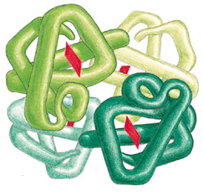  Haem group
(a) | (i) | With reference to haemoglobin, describe the quaternary structure of proteins.
 | (ii) | It has been found that all human haemoglobin molecules always have identical tertiary structure. Explain why this is so.
 | (iii) | The oxygen transport ability of haemoglobin is affected by extreme pH conditions. Explain why this is so.
 |  | [5]
(b) | Besides oxygen, carbon monoxide is also able to attach itself to haemoglobin (Hb). In fact, carbon monoxide competes with oxygen for the same binding sites on haemoglobin, and an equilibrium exists between oxyhaemoglobin and carboxyhaemoglobin.  CO + Hb-O₂ Hb-CO + O₂ K_{stab} = 240
 | (i) | Explain why CO is able to act as a ligand.
 | (ii) | Using the above information, state the type of reaction for the above equilibrium and explain why carbon monoxide is toxic.
 | (iii) | Suggest a method that could be used to treat patients suffering from carbon monoxide poisoning.
 |  | [4]
(c) | (i) | Using the following data, and relevant data from the Data Booklet, construct a Born-Haber cycle to calculate the lattice energy of MgCl₂.
   | ΔH / kJ mol ⁻¹
  Enthalpy change of atomization of magnesium | +148
  First electron affinity of chlorine | −349
  Enthalpy change of formation of magnesium chloride | −641.8
 | (ii) | The theoretical lattice energy for MgCl₂ is −2542 kJ mol⁻¹. Explain the discrepancy between this value and the experimental value calculated in (c)(i).
 |  | [6]
(d) | Sodium, magnesium and aluminium are all metals, but their chlorides differ in their reactions with water. Write equations for sodium chloride, magnesium chloride and aluminium chloride in water. Suggest a pH value for each of these aqueous chlorides.
 |  | [3]
(e) | In an experiment, 50 cm³ solution of 1.0 mol dm⁻³ MgCl₂ was added to a 50 cm³ solution of 2.0 mol dm⁻³ NaOH. The resulting mixture showed a pH of 10.2.  Calculate the solubility product of the precipitate formed, including its units.
 |  | [2]
 |  | [Total 20m]
4 | Copper(II) bromide is used in photographic processing as an intensifier and as a brominating agent in organic synthesis. Bromine, which can be obtained from copper(II) bromide industrially, is used in organic synthesis to form alkyl bromides.
(a) | A solution of concentrated CuBr₂ is electrolysed with a current of 3 A for an hour.
 | (i) | State the products formed at the anode and cathode.
 | (ii) | Calculate the mass of the product formed at the cathode.
 |  | [5]
 | [The use of the Data Booklet is relevant to this question]
(b) | Bromine reacts with 2-methylpropane in the presence of sunlight to produce mono-brominated products via a free radical mechanism.
 | (i) | Explain why the mono-bromination of 2-methylpropane results in the formation of two products in unequal amounts.
 | (ii) | How will the reactivity of fluorine with 2-methylpropane compare with that of bromine? Explain.
 | (iii) | Explain why the reaction between iodine and 2-methylpropane is reversible.
 |  | [5]
(c) | An organic compound J, with molecular formula C₅H₁₁Br, reacts with hot ethanolic KOH to give two products K and L with the same molecular formula C₅H₁₀. Compound K exhibits stereoisomerism while compound L does not.  When compound L is heated strongly with acidified potassium permanganate(VII), a product M is produced together with a colourless gas that turns limewater cloudy.  A sweet smelling compound N is formed when compound M is refluxed with ethanol and a bit of concentrated sulfuric acid.
 | (i) | Deduce the structures of compounds J to N, and write balanced equations for the reactions that are described.
 | (ii) | State and illustrate the type of stereoisomerism K exhibits
 |  | [10]
 |  | [Total 20m]
5(a) | A mixture of Na₂HPO₄ and NaH₂PO₄ can be used to form a biological buffer with a pH range of 6 – 7.5.
 | (i) | By means of equations, show how the above buffer works.
 | (ii) | Determine the pH of the solution formed when 50.0 cm³ of 0.100 mol dm⁻³ NaH₂PO₄(aq) is mixed with 30.0 cm³ of 0.100 mol dm⁻³ Na₂HPO₄(aq).  [pK_{a} for NaH₂PO₄ is 7.2]
 | (iii) | Calculate the change in pH when 2 cm³ of 0.1 mol dm⁻³ of hydrochloric acid is added to the solution in (a)(ii).
 |  | [6]
(b) | A thermochemical experiment was carried out to determine the heat of neutralisation for the reaction between sodium hydroxide and hydrochloric acid. 40.0 cm³ of 1.0 mol dm⁻³ HCl(aq) and 40.0 cm³ of 1.0 mol dm⁻³ NaOH(aq) were mixed and an increase in temperature of 6.5° C was recorded.  NaOH (aq) + HCl (aq) → NaCl (aq) + H₂O (l)
 | (i) | Calculate the heat of neutralisation ΔH^{θ}_{neut}.  [specific heat capacity of solution can be taken as 4.2 J cm⁻³ K⁻¹]
 | (ii) | If ΔS^{θ} for the reaction is +80.6 J mol⁻¹ K⁻¹, and using your answer to b(i), prove that the reaction is spontaneous at room temperature.
 |  | [4]
(c) | Describe and explain the difference seen when a hot glass rod is placed in two separate cylinders, one containing hydrogen chloride and the other containing hydrogen iodide.
 |  | [2]
5 | (d) | The following structure, compound D, is a derivative of folic acid and is used in the treatment of anaemia.
 |  | 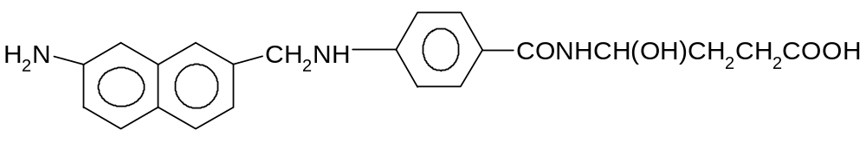
 | (i) | D has pK_{b1} = 5.8 and pK_{b2} = 9.7. Copy the above structure and assign pK_{b} values to the corresponding groups. Explain the difference in the two pK_{b} values.
 | (ii) | Starting from 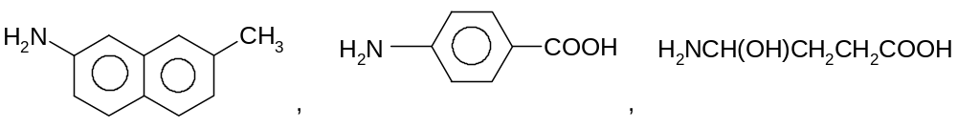 show how compound D can be synthesized, stating all relevant reagents, conditions and intermediate compounds in the synthetic pathway. ( No balanced equations are required )
 |  | [6]
 | (e) | Suggest methods by which the following compounds can be distinguished from each other by chemical tests. The distinguishing of this pair of compounds may rely on a preliminary breaking up of the compounds, and subsequent testing of the reaction products.
 |  | 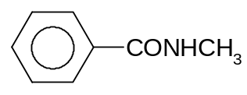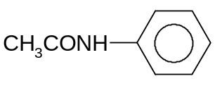
 |  | [2]
 |  | [Total 20m]

End Of Paper

